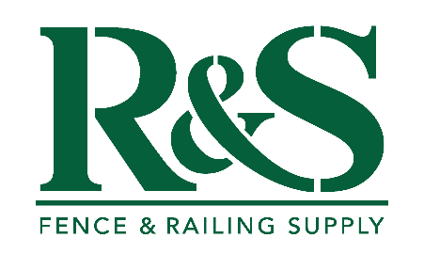
R&S Fence and Railing Supply Workmanship Warranty
At R&S Fence and Railing Supply, we stand behind the quality of our work. Our workmanship warranty is designed to give you peace of mind that your installation is built to last.
What Our Workmanship Warranty Covers:
Our workmanship warranty covers any issues that come up as a direct result of the installation itself. That means if a post becomes loose, a gate doesn’t function properly, or something shifts because of how it was installed, we’ll take care of it.
What Our Workmanship Warranty Does Not Covers:
What the warranty doesn’t cover are things outside of installation quality, including
- Storm damage
- Normal ground movement
- General wear and tear
- Materials defects (Those are covered separately under the manufacturer’s warranty)
Our Commitment:
While the warranty is written as one year, our commitment to our customers goes beyond that. We stand behind our work and will always be here to make sure your fence performs the way it should.

